MENU NAVEGAÇÃO + LOGO - Header

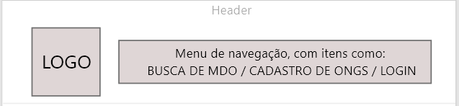

Bethany (free css templates)



E quanto rolamos a pagina..



Thinker (free css templates)



E quanto rolamos a pagina..



Como funciona:

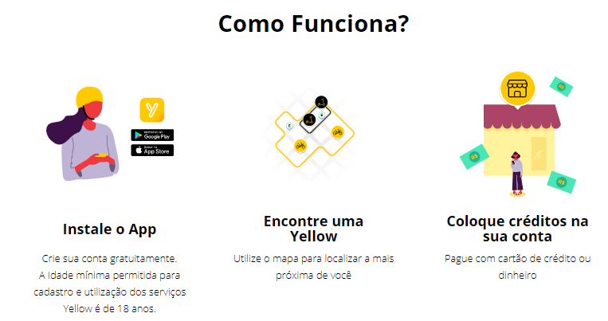YELLOW

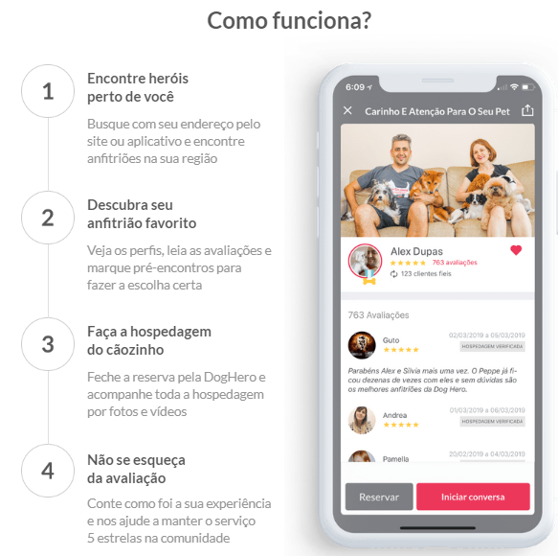DOGHERO

TINKER (free css templates)

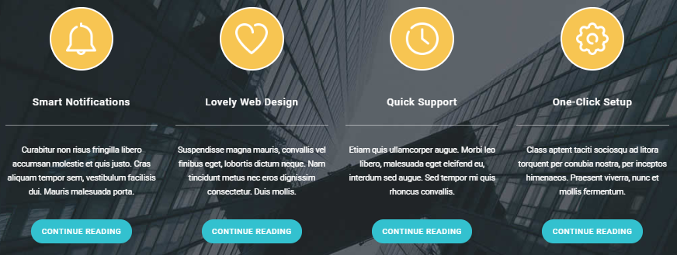

FREE CSS TEMPLATES:

<https://www.free-css.com/free-css-templates/page225/bikin>

<https://www.free-css.com/free-css-templates/page227/charity>

<https://www.free-css.com/free-css-templates/page226/pentagon>

<https://www.free-css.com/free-css-templates/page229/catalyst>

<https://www.free-css.com/free-css-templates/page228/day>

<https://www.free-css.com/free-css-templates/page239/bethany>

<https://www.free-css.com/free-css-templates/page243/tinker>

OUTROS SITES DE REFERENCIA:

<https://www.yellow.app/como-alugar-uma-yellow>

<https://www.doghero.com.br/>

<https://www.airbnb.com.br/?logo=1>